Que 1) Plot a histogram,

10, 13, 18, 22, 27, 32, 38, 40, 45, 51, 56, 57, 88, 90, 92, 94, 99

**Answer –**

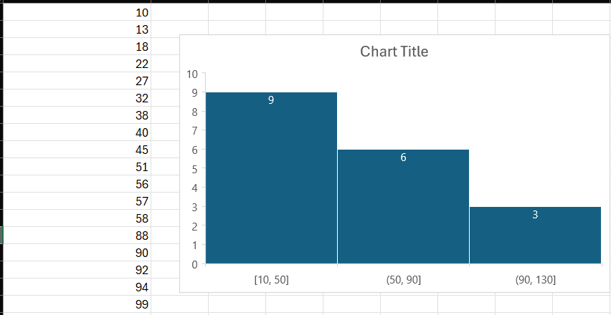

Que 2) In a quant test of the CAT Exam, the population standard deviation is known to be 100. A sample of 25 tests taken has a mean of 520. Construct an 80% CI about the mean.

**Answer –**

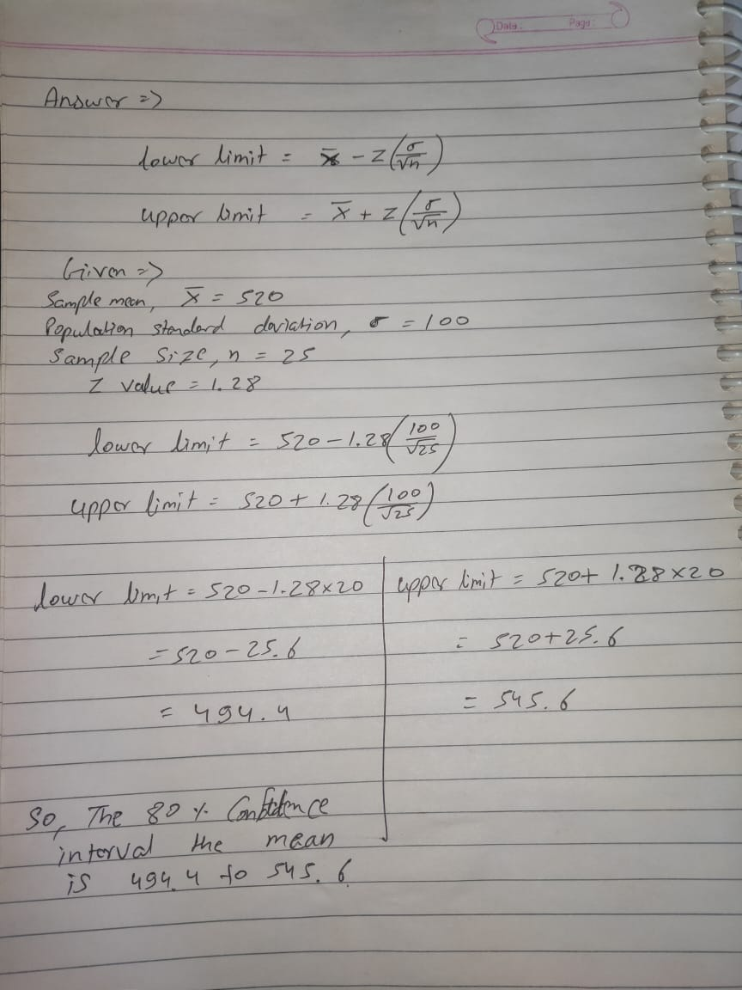

Que 3) A car believes that the percentage of citizens in city ABC that owns a vehicle is 60% or less. A sales manager disagrees with this. He conducted a hypothesis testing surveying 250 residents & found that 170 residents responded yes to owning a vehicle.

1. State the null & alternate hypothesis.
2. At a 10% significance level, is there enough evidence to support the idea that vehicle owner in ABC city is 60% or less.

**Answer –**

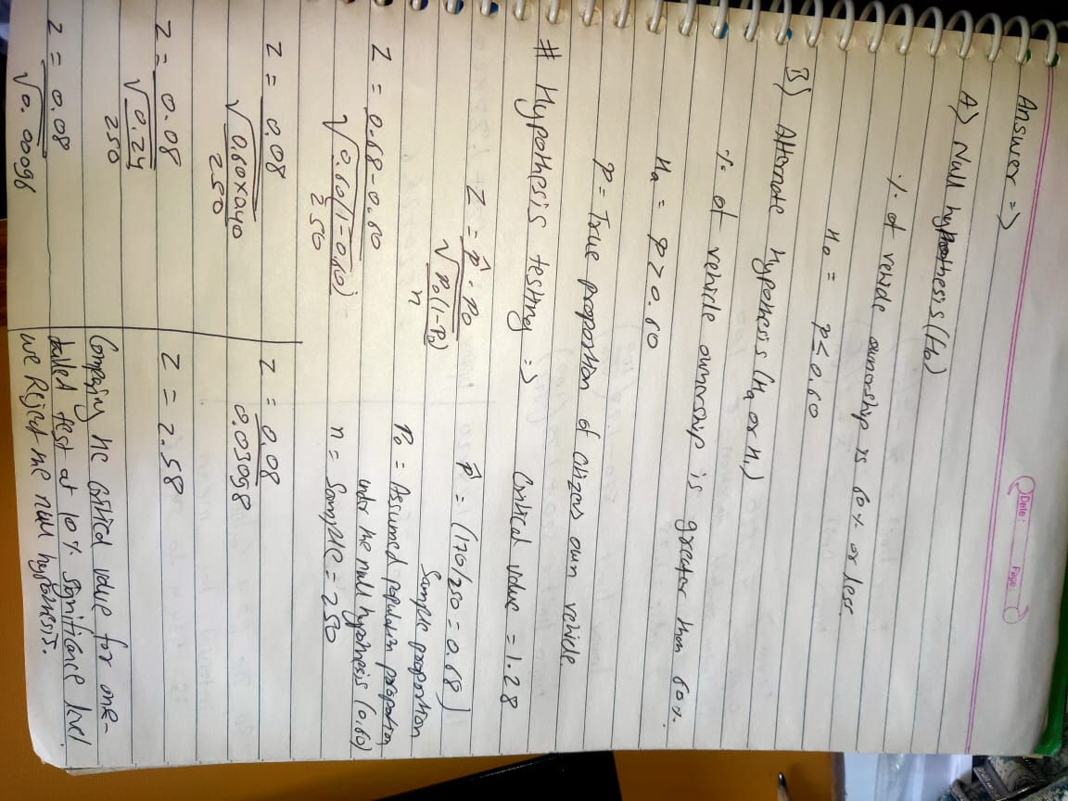

Que 4) What is the value of the 99 percentile?

2,2,3,4,5,5,5,6,7,8,8,8,8,8,9,9,10,11,11,12

**Answer –**

Que 5) In left & right-skewed data, what is the relationship between mean, median & mode?

Draw the graph to represent the same.

**Answer –** In left-skewed (negatively skewed) and right-skewed (positively skewed) distributions, the relationship between the mean, median, and mode tends to follow a general pattern:

Left-Skewed Distribution:

Mean < Median < Mode

The mean is typically less than the median, and the median is less than the mode.

The tail of the distribution extends more to the left, and there are relatively more lower values.

Right-Skewed Distribution:

Mode < Median < Mean

The mean is typically greater than the median, and the median is greater than the mode.

The tail of the distribution extends more to the right, and there are relatively more higher values.

